25.77: a) 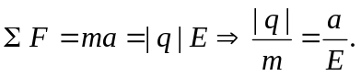
b) If the electric field is constant, 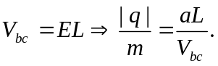
c) The free charges are “left behind” so the left end of the rod is negatively charged, while the right end is positively charged. Thus the right end is at the higher potential.
d) 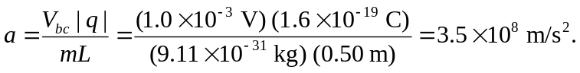
e) Performing the experiment in a rotational way enables one to keep the experimental apparatus in a localized area—whereas an acceleration like that obtained in (d), if linear, would quickly have the apparatus moving at high speeds and large distances.

